FIRST! Call your bank and tell them that you are doing a transaction on an Indian website. Many are having issues with the bank rejecting the Visa fee charge because it is from an Indian website
(high fraud areas).
Go to https://indianvisaonline.gov.in/visa/index.html
Click on e-Tourist Visa application

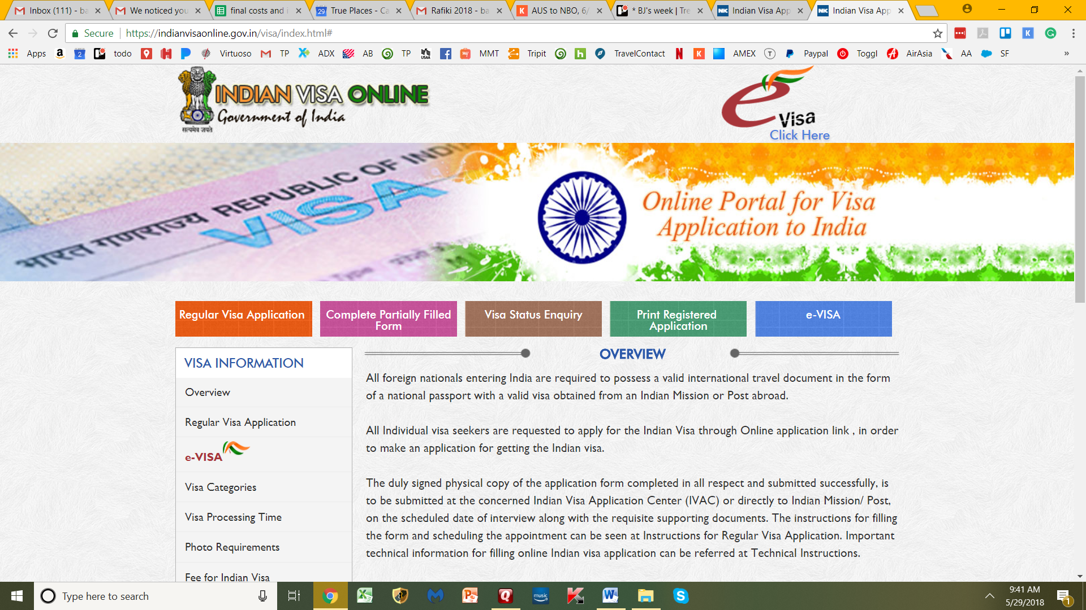
Then
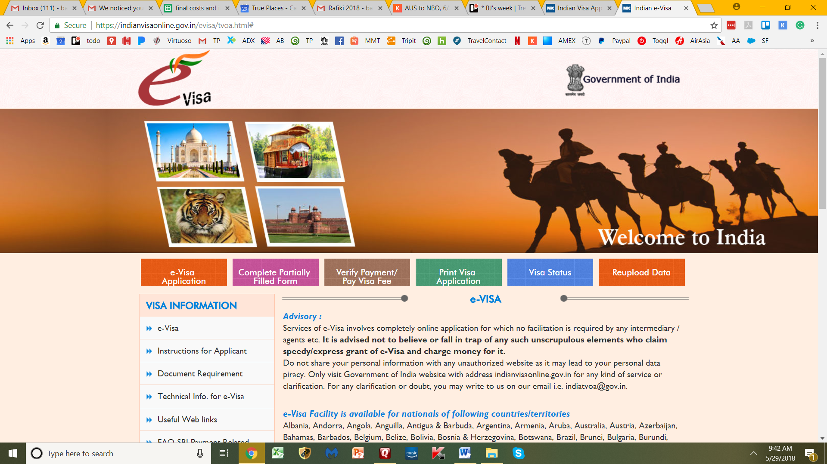
Fill out this page and remember to put the day you LAND in India, not the day you depart USA

You likely have an ORDINARY passport. You will know if you have anything different.
You land in DELHI/MUMBAI (put the first Indian city noted on your travel itinerary) – where you depart from is not so important but go ahead and follow your itinerary
Note that the date of birth format is DD/MM/YYY
Ensure you put every name shown in your passport! First AND Middle AND Last.
Then fill the rest as personal (if in doubt use my answer where appropriate). Watch format of DATES!

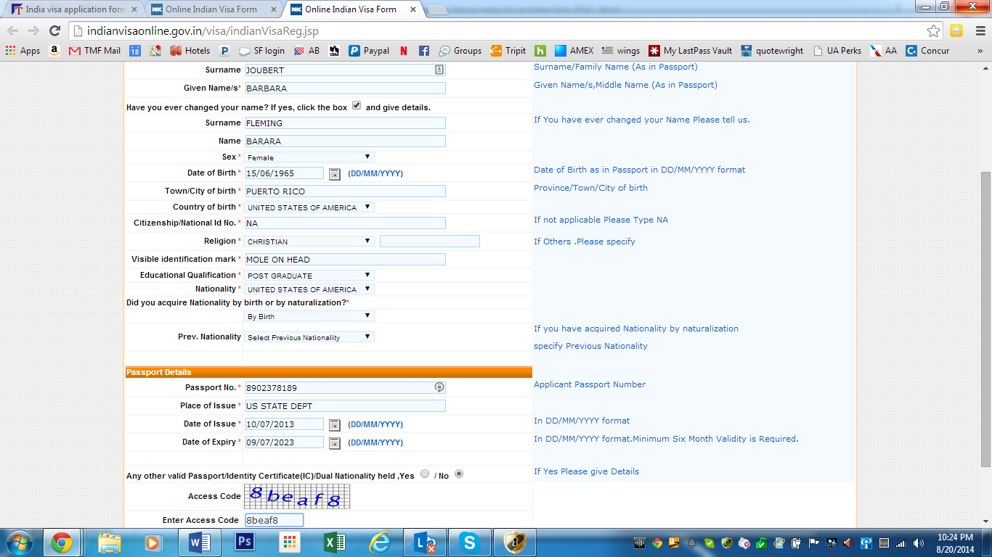
Place of birth – I put the STATE not the city because that is what is on your passport.
Citizenship/National ID – put NA
Visible id marks – put a tattoo, scar, birthmark, etc
Educational qualification - put POST Graduate
Have you lived in the country you are applying for a Visa for more than 2 years? – YES You are applying from USA and you have lived here more than 2 years. Don’t question this…just click YES!
Then save and continue…now, if it won’t save – you just have to keep trying. If after several attempts, then you have to start again. Sorry…
If you get through:

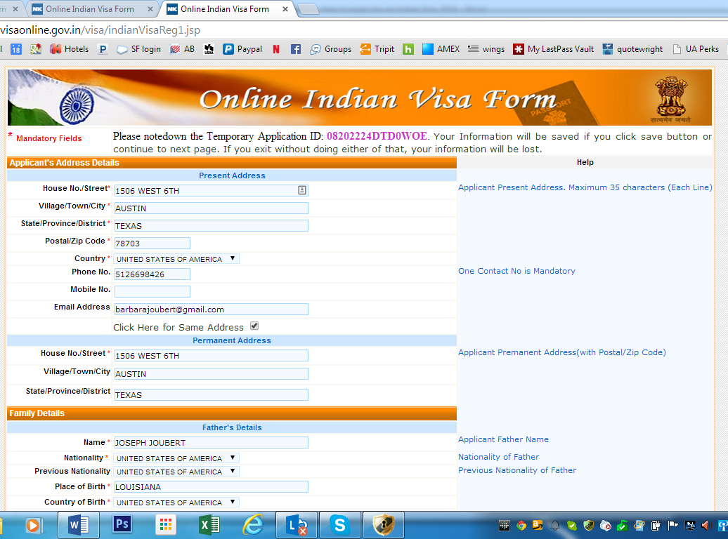
If you don’t know either Father or Mother details, take a guess. They just want to know they’re NOT from Pakistan! If they are deceased, put their details anyway.
Place of birth – I put the STATE not the city.
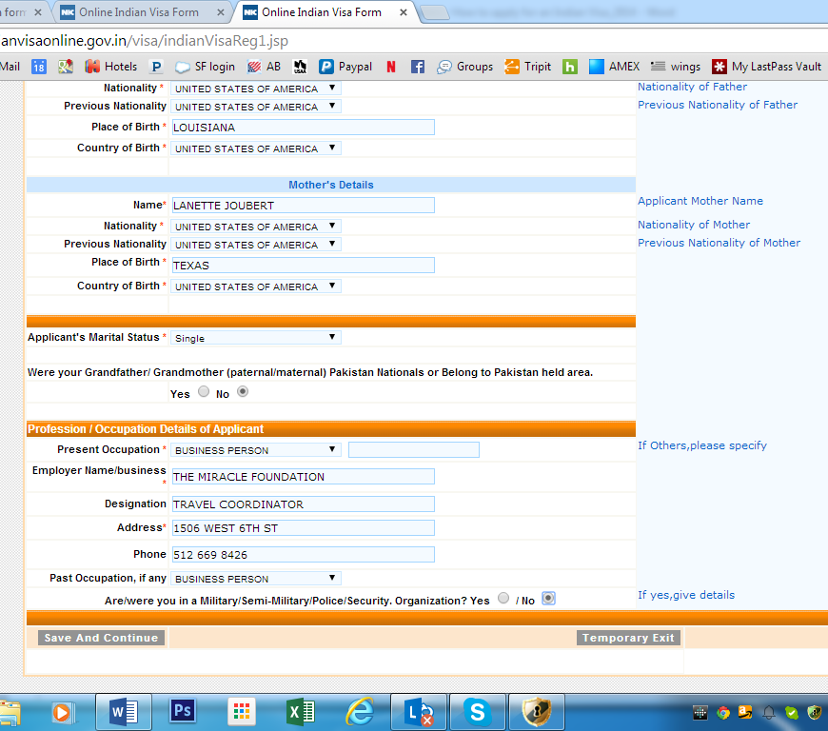
Please do not use “Charity/Social Worker” – “Business Person” works for anyone who can’t find anything to match.
Save and continue
The next page is for the Visa and most is filled out.
- double entry – this is ok
- 60 days validity – this is ok
- Tourism purpose – ONLY! Do not put anything but TOURISM!- SIGHTSEEING
- Have you lived in the country you are applying for a Visa for more than 2 years? – YES You are applying from USA and you have lived here more than 2 years. Don’t question this…just click YES!

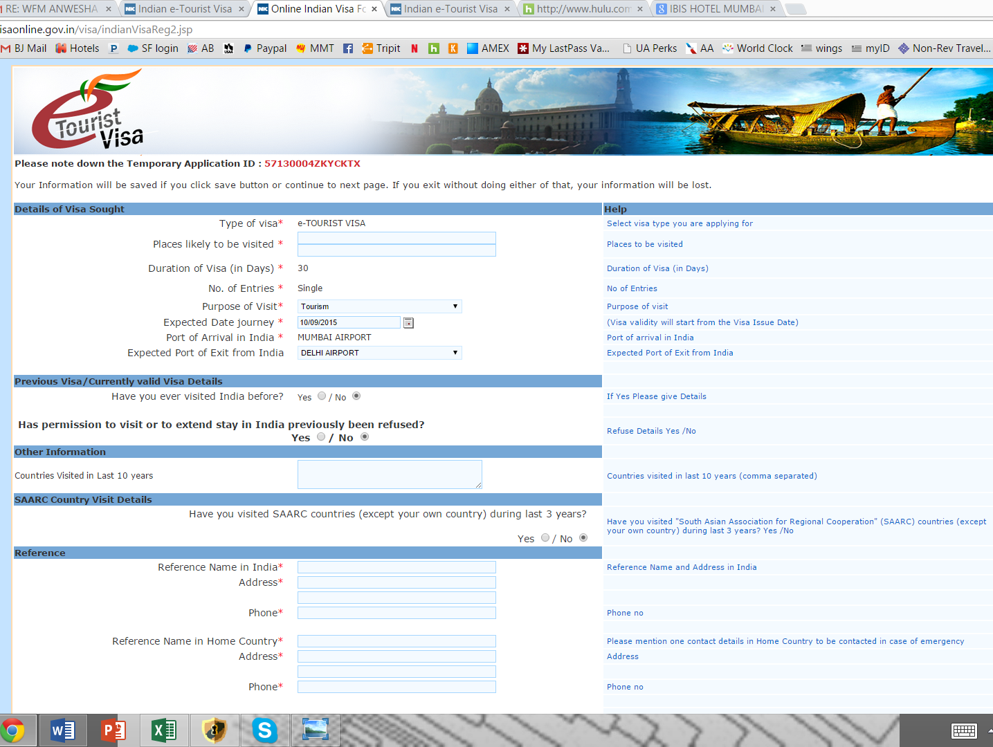
Notes for this page:
Copy and paste the places to visit as:
Mumbai, Delhi, Hyderabad and, Agra (if you are doing Taj Mahal), and Kerala (if you are doing the backwaters trip).
Remember - ONLY ask for TOURISM Visa! Sightseeing only.
Copy and paste this as the reference names in India:
Delhi travelers: Novotel New Delhi Aerocity
Address: Asset No 02, GMR Hospitality District, Aerocity, IGI Airport, New Delhi, Delhi 110037, India
Phone: +91 11 4608 0808

Mumbai travelers:
Taj Mahal Palace
Address: Apollo Bandar, Colaba, Mumbai, Maharashtra 400001, India
Phone: +91 22 6665 3366

Copy and paste this as the reference names in USA:
Barbara Joubert
902 Gardner Rd #8
Austin, Tx USA 78721
ph - +15126698426

Upload photos according to these rules:
The documents required for e-Tourist Visa (eTV) are :
- Scanned First Page of Passport.
  - Format -PDF
  - Size : Minimum 10 KB ,Maximum 300 KB
The digital photograph to be uploaded along with the Visa application should meet the following requirements:
- Format – JPEG
- Size
  - Minimum 10 KB
  - Maximum 1 MB
- The height and width of the Photo must be equal.
- Photo should present Full face, front view, eyes open.
- Center head within frame and present full head from top of hair to bottom of chin.
- Background should be plain light colored or white background.
- No shadows on the face or on the background.
- Without borders.

Note – this can be taken on your cellphone. You do not have to go get passport photos. 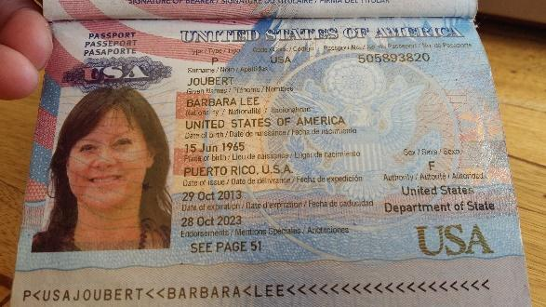

Then it should jump to the payment page. Using a credit card (usually a debit card doesn’t work) Click on AXIS bank portal. Fill in and submit. You should get a confirmation email. Then you wait 24-48 hours and whallah! Once the Visa is received by email, forward to me asap.
I’m available for questions. Good Luck!
Barbara

